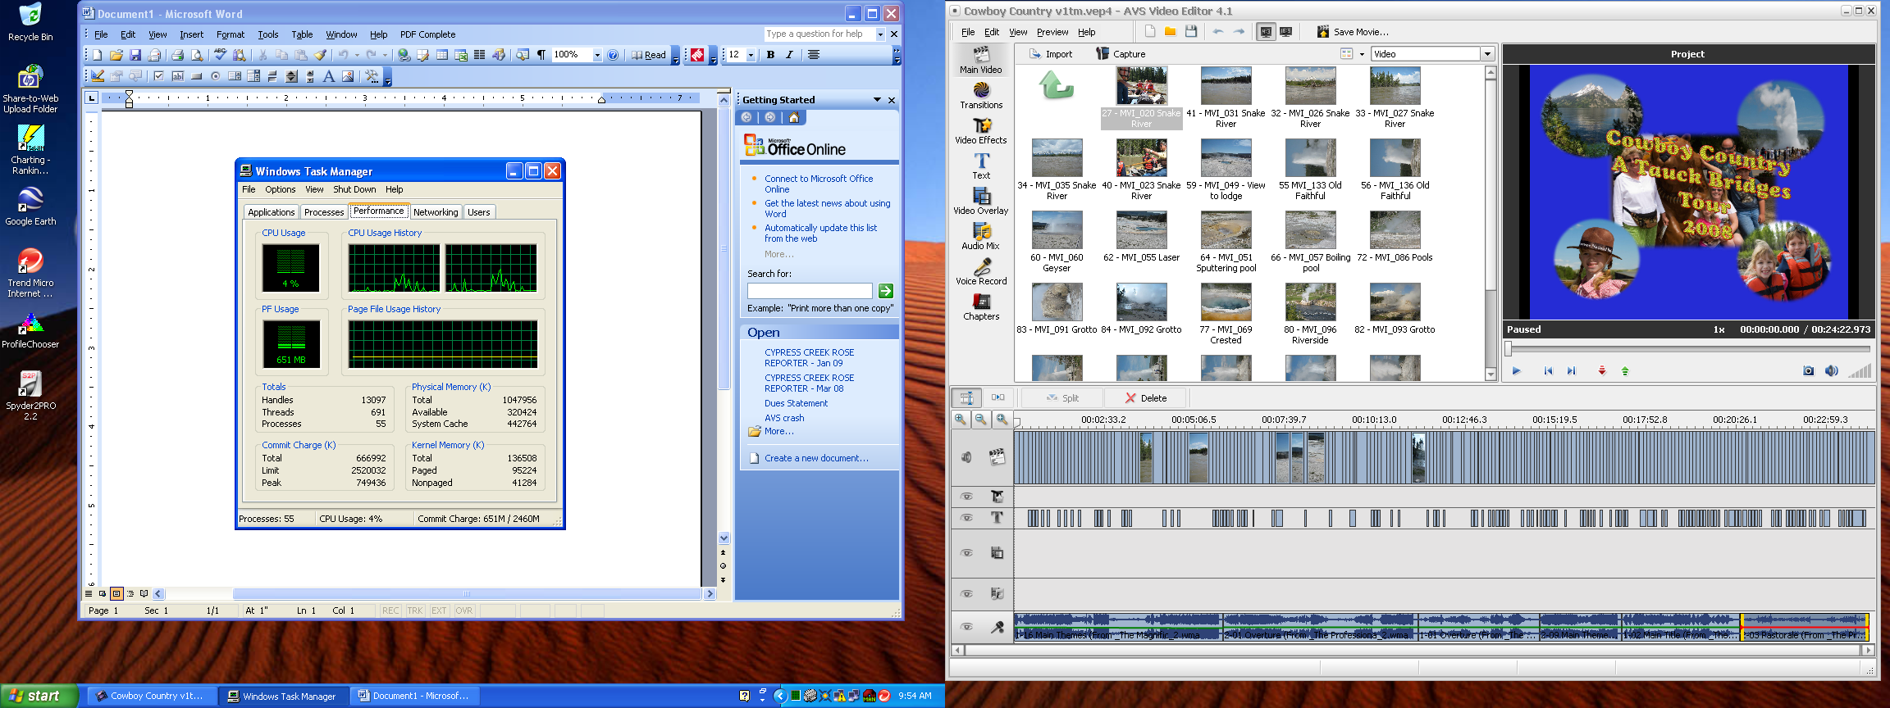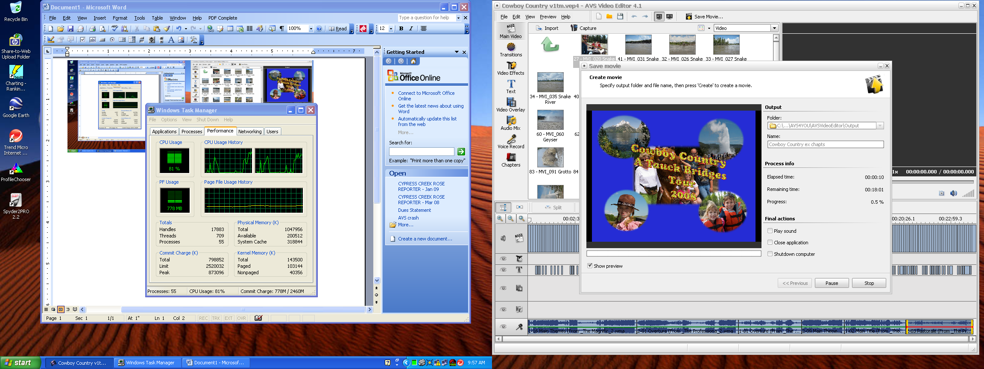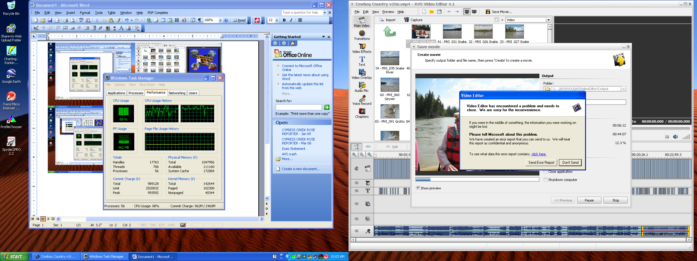

Performance data is hard to read, I had to go to 300% to be satisfactory.

Totals Handles Threads Processes
Before 13097 691 55 Before coversion begun
At Start 17883 709 55 Just after conversion begun
At Crash 17763 706 56 Just after crash occurred

Physical
Memory Total Available System Cache
Before 1047956 320424 442764
At Start 1047956 200512 318844
At Crash 1047956 111160 172884

Commit
Charge Total Limit Peak
Before 666992 2520032 749436
At Start 798852 2520032 873096
At Crash 989128 2520032 993592

Kernel
Memory Total Paged Nonpaged
Before 136508 95224 41284
At Start 143500 103144 40356
At Crash 142644 102300 40344

